**Mars Orbiter Mission**

As we all know Classical mechanics is the study of the motion of bodies ,of which Circular motion by which a body executes a circular orbit about another fixed body.

here the geometry of orbital motion of sun mars and mangalyaan the orbiter is considered in an elliptical orbit around the mars by MOM (mars orbiter mission mangalyaan).

The orbital motion between sun and mars ,along with the earth’s motion is considered in such a way that our MOM should be injected to finally lock to orbit around mars. this type of opportunity we get roughly once in 2 years ,also the journey from earth to mars would take around 300 days

Specifically, if u r asking about classical mechanics…then everything, every step, even starting from the word itself - “journey to the moon” classical mechanics starts its action.

And yes, im not answering as if i know every inch of the project, its working…its just an overview that at least every curious people can know, even if not into that depth.

So, the Journey to be travelled by the rocket-its build up, trajectory, motion, proppelling system, finding out its suitable orbit, escape velocity everything has got to seek help of classical mechanics.

On the other hand, relation of moon vs earth motion, its location at certain time, its rotation, revolution, gravity which plays major role in fixing orbit for the ship, landing technique, descent speed, exhaust force too demand concepts of classical mechanics.

-------------------------------------------------------------------------

The MOM probe spent about a month in [Earth orbit](https://en.wikipedia.org/wiki/Geocentric_orbit), where it made a series of seven [apogee-raising](https://en.wikipedia.org/wiki/Orbit_raising) [orbital manoeuvres](https://en.wikipedia.org/wiki/Orbital_maneuver) before [trans-Mars injection](https://en.wikipedia.org/wiki/Trans-Mars_injection) on 30 November 2013 ([UTC](https://en.wikipedia.org/wiki/Coordinated_Universal_Time)).[[23]](https://en.wikipedia.org/wiki/Mars_Orbiter_Mission#cite_note-isro20131202-23) After a 298-day transit to Mars, it was put into Mars orbit on 24 September 2014

It was launched on 5 November 2013 by the Indian Space Research Organisation (ISRO).

Launch opportunities for a fuel-saving **Hohmann transfer orbit** occur every 26 months, in this case the next two would be in 2016 and 2018.

In [orbital mechanics](https://en.wikipedia.org/wiki/Orbital_mechanics), the **Hohmann transfer orbit** is an [elliptical orbit](https://en.wikipedia.org/wiki/Elliptical_orbit) used to transfer between two [circular orbits](https://en.wikipedia.org/wiki/Circular_orbit) of different radii around the same body in the same [plane](https://en.wikipedia.org/wiki/Plane_(geometry)).

The Hohmann transfer orbit uses the lowest possible amount of [energy](https://en.wikipedia.org/wiki/Energy) in traveling between these orbits.

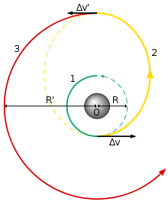

When used to move a spacecraft from orbiting one planet to orbiting another, the situation becomes somewhat more complex, but much less delta-*v* is required, due to the [Oberth effect](https://en.wikipedia.org/wiki/Oberth_effect), than the sum of the delta-*v* required to escape the first planet plus the delta-*v* required for a Hohmann transfer to the second planet.

For example, consider a spacecraft travelling from the [Earth](https://en.wikipedia.org/wiki/Earth) to [Mars](https://en.wikipedia.org/wiki/Mars). At the beginning of its journey, the spacecraft will already have a certain velocity and kinetic energy associated with its orbit around Earth. During the burn the rocket engine applies its delta-*v*, but the kinetic energy increases as a square law(Concept of Classical Mechanics), until it is sufficient to [escape the planet's gravitational potential](https://en.wikipedia.org/wiki/Escape_velocity), and then burns more so as to gain enough energy to get into the Hohmann transfer orbit (around the [Sun](https://en.wikipedia.org/wiki/Sun)). Because the rocket engine is able to make use of the initial kinetic energy of the propellant, far less delta-*v* is required over and above that needed to reach escape velocity, and the optimum situation is when the transfer burn is made at minimum altitude (low [periapsis](https://en.wikipedia.org/wiki/Periapsis)) above the planet. The delta-*v* needed is only 3.6 km/s, only about 0.4 km/s more than needed to escape Earth, even though this results in the spacecraft going 2.9 km/s faster than the Earth as it heads off for Mars (see table below).

At the other end, the spacecraft will need a certain velocity to orbit Mars, which will actually be less than the velocity needed to continue orbiting the Sun in the transfer orbit, let alone attempting to orbit the Sun in a Mars-like orbit. Therefore, the spacecraft will have to decelerate in order for the [gravity of Mars](https://en.wikipedia.org/wiki/Gravity_of_Mars) to capture it. This capture burn should optimally be done at low altitude to also make best use of Oberth effect. Therefore, relatively small amounts of thrust at either end of the trip are needed to arrange the transfer compared to the free space situation.

However, with any Hohmann transfer, the alignment of the two planets in their orbits is crucial – the destination planet and the spacecraft must arrive at the same point in their respective orbits around the Sun at the same time. This requirement for alignment gives rise to the concept of [launch windows](https://en.wikipedia.org/wiki/Launch_window).

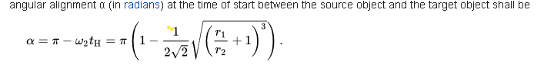



**Mission profile**

**Geocentric Phase**

A geocentric orbit or Earth orbit involves any object orbiting the Earth, such as the Moon or artificial satellites

A spacecraft enters orbit when its centripetal acceleration due to gravity is less than or equal to the centrifugal acceleration due to the horizontal component of its velocity.

Spacecraft with a perigee below about 2,000 km (1,200 mi) are subject to drag from the Earth's atmosphere, which decreases the orbital altitude. The rate of orbital decay depends on the satellite's cross-sectional area and mass, as well as variations in the air density of the upper atmosphere. Below about 300 km (190 mi), decay becomes more rapid with lifetimes measured in days. Once a satellite descends to 180 km (110 mi), it has only hours before it vaporizes in the atmosphere.[6] The escape velocity required to pull free of Earth's gravitational field altogether and move into interplanetary space is about 11,200 m/s.

Elliptic orbit - An orbit with an eccentricity greater than 0 and less than 1 whose orbit traces the path of an ellipse.

Hohmann transfer orbit - An orbital maneuver that moves a spacecraft from one circular orbit to another using two engine impulses.

Escape Trajectory - This trajectory must be used to launch an interplanetary probe away from Earth, because the excess over escape velocity is what changes its heliocentric orbit from that of Earth.

Capture Trajectory - This is the mirror image of the escape trajectory; an object traveling with sufficient speed, not aimed directly at Earth, will move toward it and accelerate. In the absence of a decelerating engine impulse to put it into orbit, it will follow the escape trajectory after periapsis.

***Trans-Mars injection***

A trans-Mars injection (TMI) is a heliocentric orbit in which a propulsive maneuver is used to set a spacecraft on a trajectory, also known as Mars transfer orbit, which will place it as far as Mars's orbit.

Every two years, low-energy transfer windows open up, which allow movement between planets with the lowest possible delta-v requirements. Transfer injections can place spacecraft into either a Hohmann transfer orbit or bi-elliptic transfer orbit. Trans-Mars injections can be either a single maneuver burn, such as that used by the NASA MAVEN orbiter, or a series of perigee kicks, such as that used by the ISRO Mars Orbiter Mission.

An areocentric orbit is an orbit around the planet Mars.

Formula

Orbital speed (how fast a satellite is moving through space) is calculated by multiplying the angular speed of the satellite by the orbital radius:

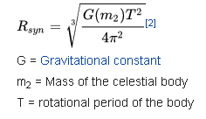

By this formula one can find the geostationary-analogous orbit of an object in relation to a given body, in this case, Mars (this type of orbit above is referred to as an areostationary orbit if it is above Mars).

The mass of Mars being 6.4171×10▲23 kg and the sidereal period 88,642 seconds[3]. The synchronous orbit thus has a radius of 20,428 km (12693 mi) from the centre of mass of Mars[4], and therefore areostationary orbit can be defined as approximately 17,032 km above the surface of the Mars equator.

EVENT

**What physics applied to Mangalyaan made its cost much less than others?**

**The Mars Orbiter Mission**

The spacecraft itself, launched November 5, 2013, had to go through a few different maneuvers before entering Mars' orbit. Initially, it was put into increasingly elliptical orbits around Earth, so that it could eventually be transferred into an orbit of the sun using minimal amounts of energy.

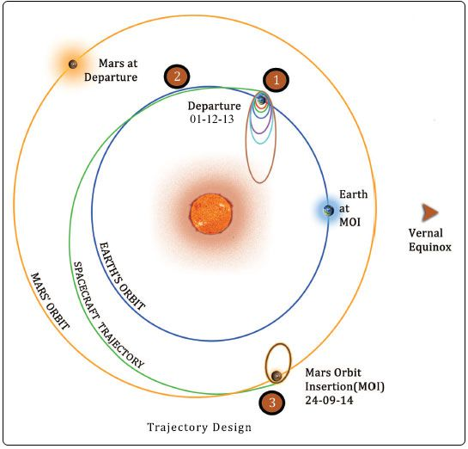

(ISRO)

After traveling around the sun for nine months and coming into the proximity of Mars, onboard thrusters fired on September 14 to push it towards Mars' orbit itself. Finally, Tuesday evening, it entered a elliptical orbit around Mars.

The craft is mainly a demonstration of the fact that India has the technology to reach Mars. But it will conduct some science during its planned six months in orbit.

In addition to cameras that will photograph Mars' surface, it's equipped with a few different instruments that will analyze the planet's atmosphere, looking for methane in particular. Scientists believe that, if methane is present, it could [be a sign of microbial life](http://exploration.esa.int/mars/46038-methane-on-mars/). Some previous crafts [have detected](https://go.redirectingat.com/?id=66960X1516588&xs=1&url=http%3A%2F%2Fwww.nature.com%2Fnews%2F2004%2F040726%2Ffull%2Fnews040726-3.html%3FsubId1%3Dxid%3Afr1572482781506idi&referrer=vox.com&xcust=xid:fr1572482781506idi) traces of methane, but the [Curiosity rover](http://www.vox.com/cards/mars-exploration/what-is-curiosity-doing-on-mars#E6602120) has failed to find any.

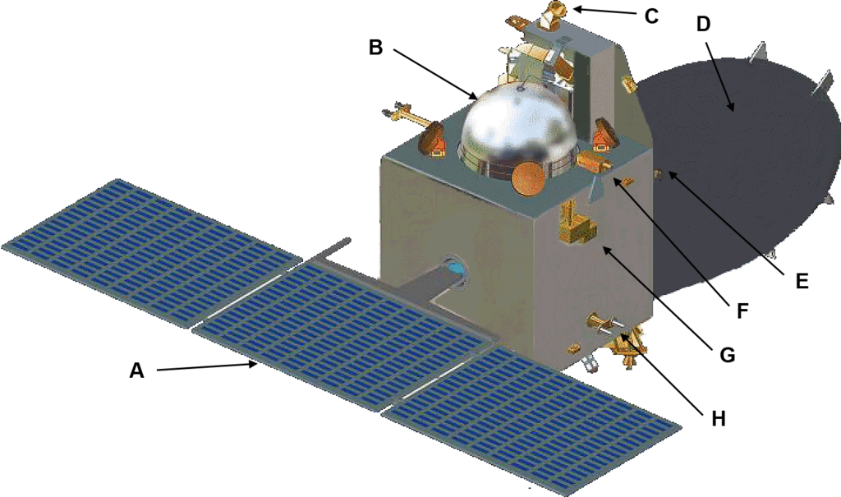

A diagram of the craft. E is the location of the camera, and F and G are the atmospheric sensing instruments ([Roland Zh](http://en.wikipedia.org/wiki/File:Mars_Orbiter_Mission_(MOM_-_Mangalyaan)_ISRO_spacecraft-with-Labels.png))

The low cost of this mission led to a number of constraints. The rocket used can only [lift so much weight](http://scienceline.org/2014/09/mom-is-circling-mars/) into Earth's orbit, capping the amount of scientific instruments that could be included on board. This is also the reason for the craft's highly elliptical orbit — such an orbit requires less fuel, further cutting down on launch weight.

But the ISRO does have another, [newer group of rockets](http://en.wikipedia.org/wiki/Geosynchronous_Satellite_Launch_Vehicle) capable of heavier launches. Many Indian scientists hope the true value of this craft will be the way it could spur ISRO to attempt future, more science-heavy missions to Mars.

Mangalyaan is equipped with a bipropellant Main Propulsion System and an Attitude Control System. The Propulsion System features two spherical propellant tanks each holding 390 liters of propellant.

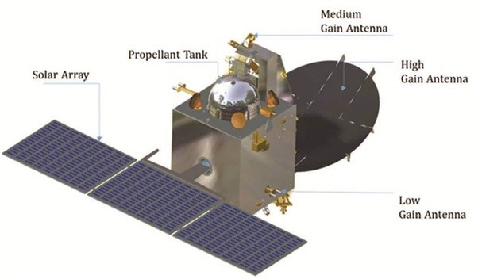

*Mangalyaan: One propellant tank is visible*

Both Main Propulsion System and Attitude Control System use Unsymmetrical Dimethylhydrazine (UDMH) as fuel and Mixed Oxides of Nitrogen [MON-3: Nitrogen Tetroxide with 3% Nitric Oxide] as oxidizer. Tank pressurization for Main Propellant System is accomplished with high-pressure Helium.